**Job Title: Customer Services Advisor**

**Reports To: Customer Services Manager / Customer Services**

**Supervisor**

**Responsible For: N/A**

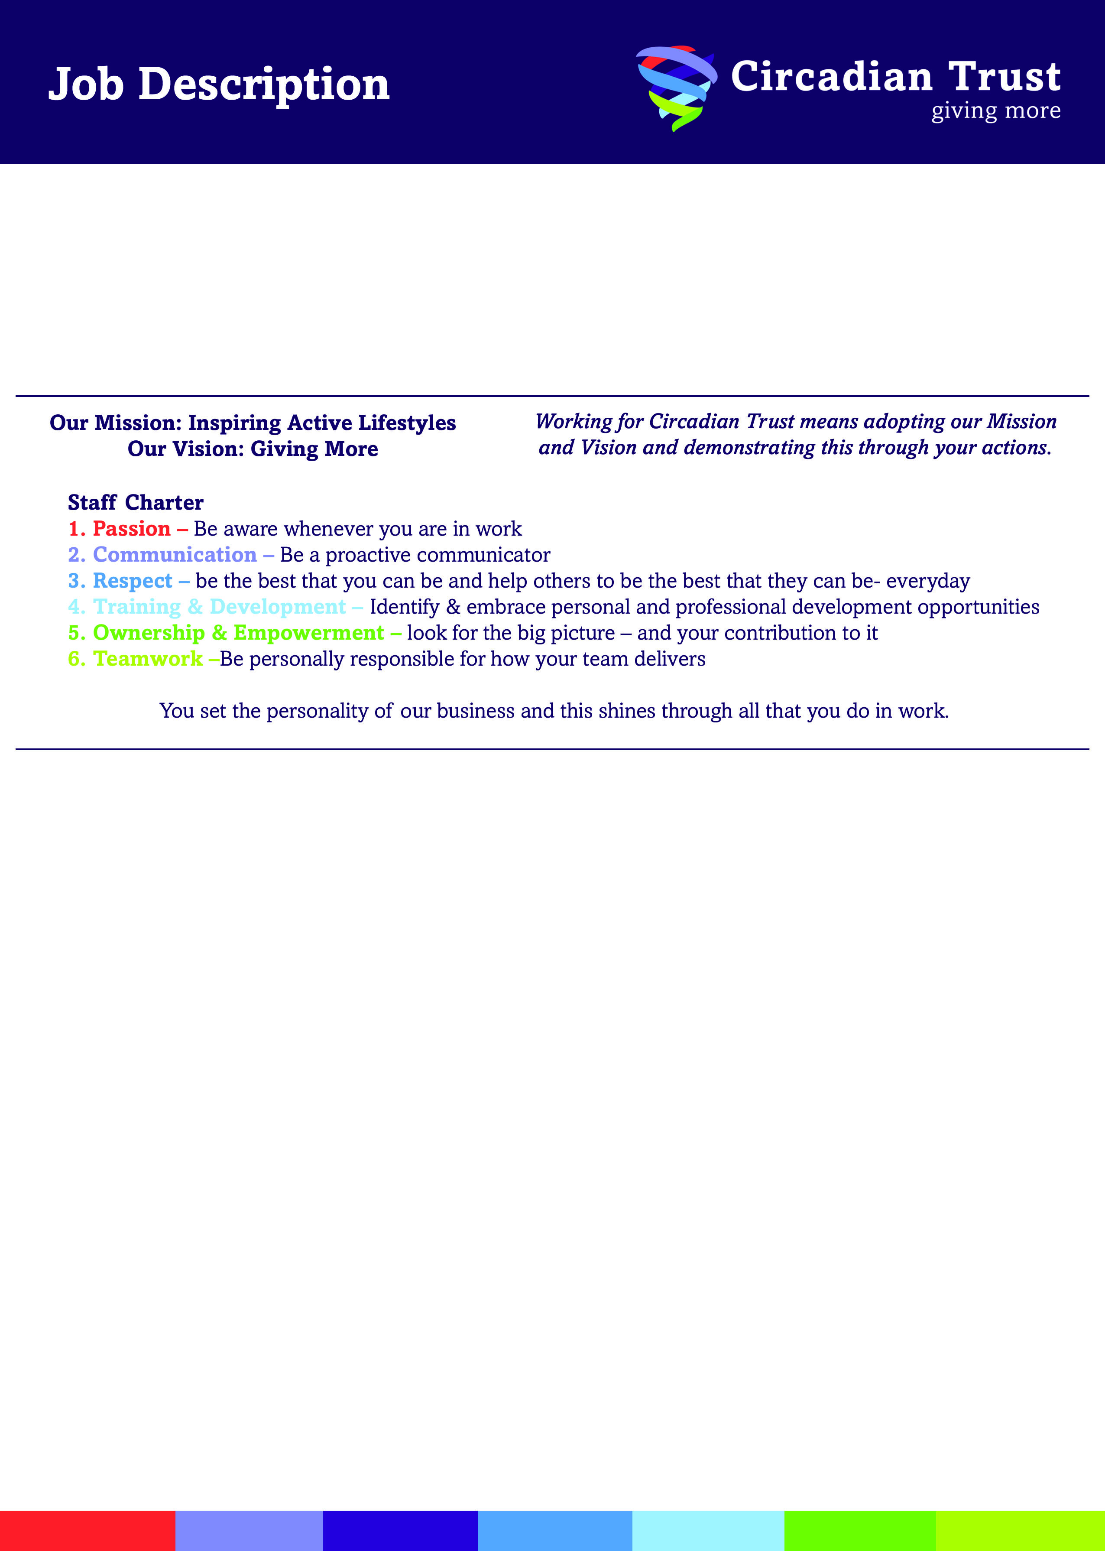

1. **JOB PURPOSE AND MAIN AIMS**

To provide an effective, friendly and efficient service to customers and to maximise membership sales and promote services to customers.

1. **SPECIFIC DUTIES AND RESPONSIBILITIES**
2. To undertake bookings and payments for activities at the centre and handle general and sales enquiries from customers.
3. To undertake tours of the facilities for customers and ensure the customers enjoy a quality experience while at the centre.
4. To carry out cash reconciliations, prepare cash for banking and undertake administrative duties as and when required.
5. To follow the Normal Operating Procedures and carry out any action as detailed in the Emergency Action Plan.
6. Maintain records of lost property.
7. Ensure that the validation/sales area is clean, tidy and efficient at all times and report any shortcomings to the Leisure Centre Manager.
8. Ensure adequate provision of literature, customer information and stationery is available in validation/sales areas and around the centre.

**And any other duties commensurate with the grade and falling within the scope of the post, as requested by Management.**

1. **SKILLS, KNOWLEDGE & EXPERIENCE (SELECTION CRITERIA)**

# Essential Criteria

1. Possess excellent customer care and verbal communication skills.
2. Experience of dealing with members of the public.
3. Ability to demonstrate a strong commitment to teamwork.
4. Experience of working in a customer focused environment.

# Desirable Criteria

1. Experience of electronic booking systems.
2. Experience of cash handling.
3. Sales experience.
4. Good written communication skills.
5. Knowledge of business IT applications (e.g. word processing/spreadsheets).

### PHYSICAL EFFORT AND/OR STRAIN

Working in a normal customer services environment.

### SPECIAL NOTES OR CONDITIONS

1. The post holder will be required to work on a shift basis, working week days, evenings and weekends.
2. The post holder will be required to wear a uniform at all times whilst on duty.
3. The post holder may be required to provide cover for colleagues from time to time.
4. The post holder will be required to undergo regular training.
5. The post holder may be required to work at any of the Leisure centres.

Date Prepared: 1st January 2015

Effective Date: 1st January 2015

Reference: R:\Job Descriptions\2015\Customer Services\Customer Services Advisor Jan 2015.doc

Insert Text Here